Chapter 3, Problem 57.

In the circuit in Fig. 3.102, find the values of R, V₁, and V₂ given that i_{o} = 15 mA.

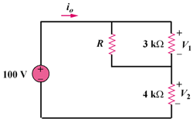

90 V

Figure 3.102
For Prob. 3.57.

